BULK ACTIVE DIRECTORY USER CREATION AUTOMATION
Documentation

1. Introduction
This document outlines the implementation of a Bulk User Creation process in Active Directory (AD) using PowerShell automation and CSV import. The project was developed to improve efficiency in user onboarding and reduce manual administrative workload within the IT support function.

2. Problem Statement
Previously, user accounts were created manually in Active Directory one by one. This process was:
- Time-consuming, especially when onboarding multiple users
- Prone to human error (missing fields, inconsistent naming)
- Inefficient for batch onboarding scenarios
3. Objective
The main objective of this project was to:
- Automate the creation of multiple AD user accounts
- Reduce time taken for user onboarding
- Improve accuracy and consistency of user account creation
- Introduce a reusable and scalable process

4. Tools & Technologies Used
- Microsoft Active Directory (AD)
- PowerShell
- Microsoft Excel (CSV preparation)
- Windows Server environment

5. Solution Overview
A CSV-based input system was created where user details are prepared in Excel and exported as a CSV file. A PowerShell script then reads the CSV file and automatically creates user accounts in Active Directory.

6. Process Workflow
- User details are entered in Excel
- File is saved as CSV format
- PowerShell script is executed as Administrator
- System reads CSV data
- User accounts are created in Active Directory
- Accounts are optionally assigned to groups and organizational units

7. CSV File Structure
The CSV file contains the following fields:
- FirstName
- LastName
- Username
- Password
- OU (Organizational Unit path)
- Department
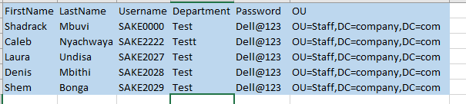
8. PowerShell Implementation Script
Import-Module ActiveDirectory
$users = Import-Csv "C:\users.csv"
foreach ($user in $users) {
$securePassword = ConvertTo-SecureString $user.Password -AsPlainText -Force
New-ADUser `
-Name "$($user.FirstName) $($user.LastName)" `
-GivenName $user.FirstName `
-Surname $user.LastName `
-SamAccountName $user.Username `
-UserPrincipalName "$($user.Username)@company.com" `
-Path $user.OU `
-AccountPassword $securePassword `
-Enabled $true `
-ChangePasswordAtLogon $true `
-Department $user.Department
}
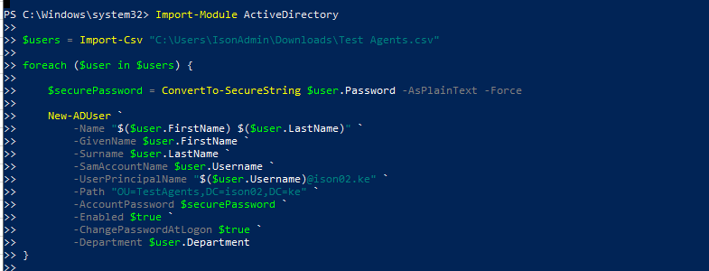

9. Results & Impact
The implementation of this solution resulted in:
- Significant reduction in time required to create multiple user accounts
- Improved consistency in user account setup
- Reduced manual workload for IT support staff
- Increased efficiency during onboarding processes
Estimated improvement:
- Manual process: ~2–3 minutes per user
- Automated process: Bulk creation in under 1 minute

10. Benefits
- Time-saving through automation
- Reduced human error
- Scalable for large onboarding batches
- Easy to reuse and modify
- Standardized user creation process

11. Challenges & Limitations
- Requires correct CSV formatting
- Dependent on accurate OU structure
- Password policies must be followed strictly
- Requires PowerShell execution permissions
Example of error handling or incorrect CSV format

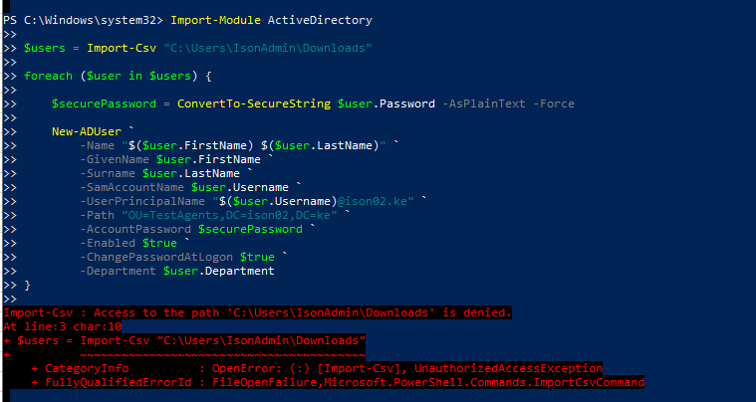

12. Conclusion
The Bulk Active Directory User Creation project successfully demonstrates process automation within IT support operations. It improves efficiency, reduces workload, and introduces a scalable solution for user onboarding.

13. Appraisal Summary (Short Version)
“I implemented a PowerShell-based automation process for bulk user creation in Active Directory using CSV import. This reduced onboarding time significantly and improved accuracy and efficiency in user account provisioning.”

END OF DOCUMENT

